Gifted Advisory Council Meeting Minutes
September 28, 2022
10:00 a.m. to 2:00 p.m.

Welcome and Call to Order
OEC Associate Director Joseph Petrarca and Gifted Advisory Council Chair Jennifer Detmar welcomed all and called the meeting to order. Council members and ODE staff introduced themselves. Meeting norms were reviewed. There were no visitors registered for public comment.

Voting Items
February 2022 meeting notes were approved with a motion by Ann Sheldon, second by Sarah Watson, and all members voting in favor.

April 2022 meeting notes were approved with a motion by Aireane Curtis, second by Denise Cooley and all members voting in favor.

Deborah Glynn self-nominated for the position of chair elect. All members voted in favor and Ms. Glynn was elected.

Overview of 3301-51-15
- Establishes the minimum requirements for identifying and serving students who are gifted
- Defines and establishes the minimum requirements for gifted education personnel, including professional development for designated providers of gifted services
- Defines and clarifies the requirements for public school districts regarding gifted identification plans, gifted education policies, and gifted service plans
- Establishes and defines the role of the Gifted Advisory Council

Proposed Revisions
- Removed duplicative language found in Ohio Revised Code
- Added clarifying language throughout
- Revised some requirements for whole grade screenings, written education plans, and gifted education professional development
- Removed duplicative language found in Ohio Revised Code
- Added clarifying language throughout
- Revised some requirements for whole grade screenings, written education plans, and gifted education professional development

Stakeholder Feedback of Rule 3301-51-15 – Operating standards for identifying and serving students who are gifted
Attendees broke into groups to discuss the draft rule, using these facilitated questions:
- Is the language in the rule clear and concise? If not, what changes are necessary?
- Is the language in the rule understandable? If not, what changes are necessary?
- How do the strike outs from the Ohio Revised Code effect the language of the rule? Does it make it difficult to understand? If so, what changes are necessary?
- What items or topics are missing in the rule?
- What guidance would help districts and families understand or implement this rule?
- What additional comments or concerns should we consider?

Timeline
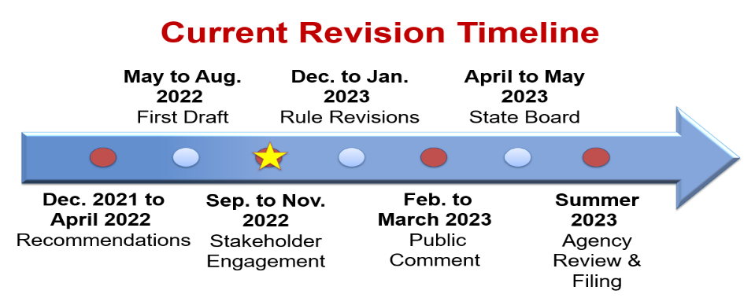

Debrief
Meeting attendees reconvened after the rule review to debrief. ODE staff asked for input on barriers and positives, as shown below.
- What barriers do you see with the proposed rule?
  - It’s possible for a school to not have gifted education in this state. That is a problem.
  - It’s also possible for this state to do what New York did.
  - A lot of these are very good, but if it comes down to funding it’s a problem.
  - The creative thinking whole screening would it be removed to screen all students for creative thinking. We need creative thinkers.
  - Disappointed that no student buy in or ownership was mentioned.
  - We need accountability for who is training gifted staff.
  - No mention of local norms, and that does not jive with the definition. This will contribute to under-representation.
  - Standard error of measurement should be mentioned.
  - We need a parent-friendly version.
  - Need to support families and parents better.
  - Gifted education can be something that create inequities.
- What positives do you see with the proposed rule?
  - Local norms and talent development.
  - Having 2E spelled out was great.
  - The collegiate discussion was great.
  - Fabulous to have the parent perspective.
  - Glad to see minimum hours of PD for outlying.
  - Liked talent development, but unclear about what that means - need more info.

Next Steps
OEC staff will review and debrief on this input. Tomorrow is the SAPEC meeting, and we will gather
their feedback. The next meeting is scheduled for December 7, 2022. Be prepared to talk about some
of the things that are coming up in gifted and our workplan for the state strategic plan for gifted
education.

The meeting was adjourned at 2:00 p.m.

